https://my.vmware.com/web/vmware/evalcenter?p=free-esxi6

https://www.golinuxhub.com/2018/02/make-bootable-pendrive-usb-linux-vmware-windows.html

*Compatibility considerations*

* *These products are not compatible with vSphere 6.5 at this time:*
  + *VMware NSX*
  + *VMware Integrated OpenStack*
  + *vCloud Director for Service Providers*
  + *vRealize Infrastructure Navigator*
  + *App Volumes*
  + *Horizon Air Hybrid-Mode*
  + *Integrated OpenStack*
  + *vCloud Networking and Security*
  + *vRealize Business for Cloud*
  + *vRealize Configuration Manager*
  + *vRealize Hyperic*
  + *vRealize Networking InsightCustomers with these products are advised to upgrade to vSphere 6.5 when compatible versions become available. For more information, see the*[***VMware Product Interoperability Matrixes***](https://partnerweb.vmware.com/comp_guide2/sim/interop_matrix.php?)*.*
* *To revert a migration to 6.5 that contains these products see,*[***Reverting a vCenter Server 5.5 or 6.0 to Appliance 6.x migration (2146453)***](https://kb.vmware.com/selfservice/search.do?cmd=displayKC&docType=kc&docTypeID=DT_KB_1_1&externalId=2146453)
* *To revert a Windows installed vCenter Server upgrade that contains these products see the Roll Back a vCenter Server Instance on Windows When vCenter Server Upgrade Fails section in the*[***vSphere Upgrade guide***](https://pubs.vmware.com/vsphere-65/topic/com.vmware.vsphere.upgrade.doc/GUID-23D2FB9E-A3A8-413E-A234-0B0DB77A1CF3.html)*.*

After loading the image it will prompt with warning message as

[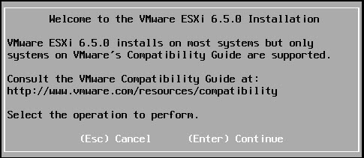](https://2.bp.blogspot.com/-3l5o4o-SiqQ/WpUBRxVy9pI/AAAAAAAAUA0/sPLyvK0QWSwGhVR8EwDnvNKAqJnm7lSWgCLcBGAs/s1600/image1.jpg)

Enter to continue the setup

[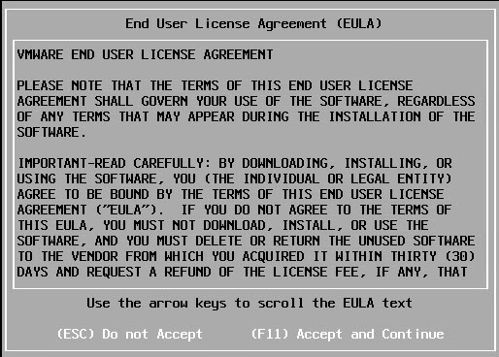](https://2.bp.blogspot.com/-D6VXDdlVeqc/WpUBirpCQgI/AAAAAAAAUA4/JRNeegwSFeYKnh0I9AthxybxbFTB1f8OwCLcBGAs/s1600/image2.jpg)

Press F11 to accept the License Agreement and continue  
  
It will load all the available devices on the server and prompt for selecting storage devices. It will show all the local and remote storage devices. here I have only one storage device so I will select it and enter to continue

[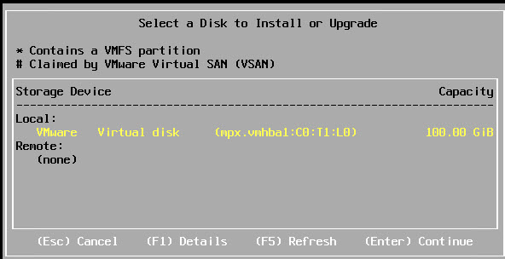](https://4.bp.blogspot.com/-7uaysM6p7ec/WpUCBwbk1nI/AAAAAAAAUBE/5w4OiALm-9kfEkQDFzcWKhf7X4OlEQnDACLcBGAs/s1600/image3.jpg)

Select the keyboard layout you are using. here I am using US so selecting the US defaultkeyboard layout

[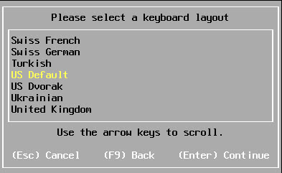](https://2.bp.blogspot.com/-_k_FDHiT5BU/WpUCeTDu_1I/AAAAAAAAUBI/E1UgQKbNpLICTEWtz0I0isSe4a9_LLi3QCLcBGAs/s1600/image4.jpg)

Enter the root password to manage the server and enter to continue

[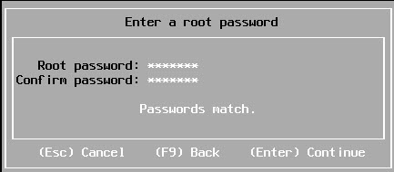](https://1.bp.blogspot.com/-OOotOH7FsAk/WpUC4oR6JNI/AAAAAAAAUBM/XRZ18r3Jq_IUzdbGKpFt2pXdVxOCgf9_wCLcBGAs/s1600/image5.jpg)

Press F11 to start the installation

[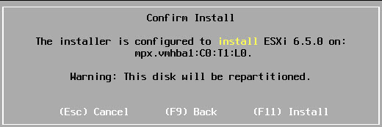](https://3.bp.blogspot.com/-odXwIZtTYSY/WpUDbfQ0OeI/AAAAAAAAUBY/K4OgOtBIpQ4z1tYHJf7p3JCvWXlC199gACLcBGAs/s1600/image6.jpg)

Once the installation is completed remove the DVD or Pen-drive and press Enter to reboot the server.

[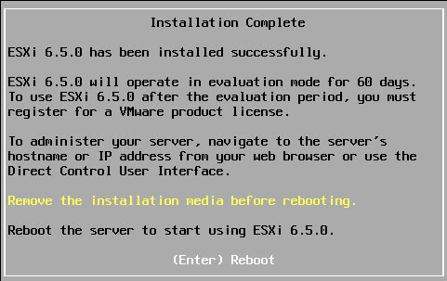](https://4.bp.blogspot.com/-7IhisBAef9Y/WpUJvwnickI/AAAAAAAAUCE/lK05P9Sfec0fOQjyUBM5WqjDuHutjrJqQCLcBGAs/s1600/image7.jpg)

Once the server is UP post reboot it will start loading the Esxi 6.5 which will take a while.  
Wait for the below screen to appear on the console

[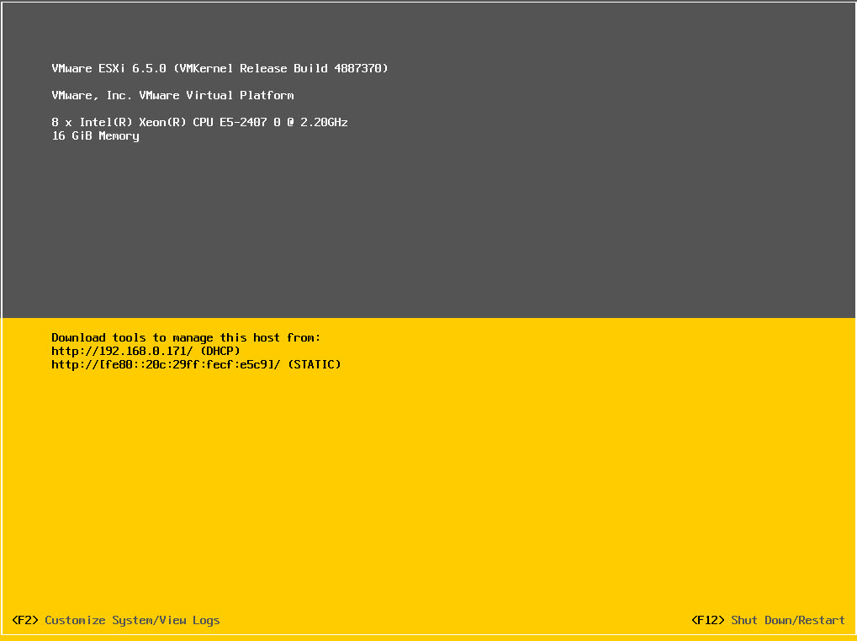](https://4.bp.blogspot.com/-2V8gn906SGE/WpUKZdHhsdI/AAAAAAAAUCM/FnEmnl0Xxj8Hp1M8ASm1arfD4fQ2DnolgCLcBGAs/s1600/image8.jpg)

If you have the DHCP server in the network it will take the IP automatically. you can use this IP to access vSpere web client or you can follow below steps to configure the static IP to the network:

#### Configure Static network for the ESXi

1. Click F2 to Customise system. Enter the root password which we have set at the time of installation.

[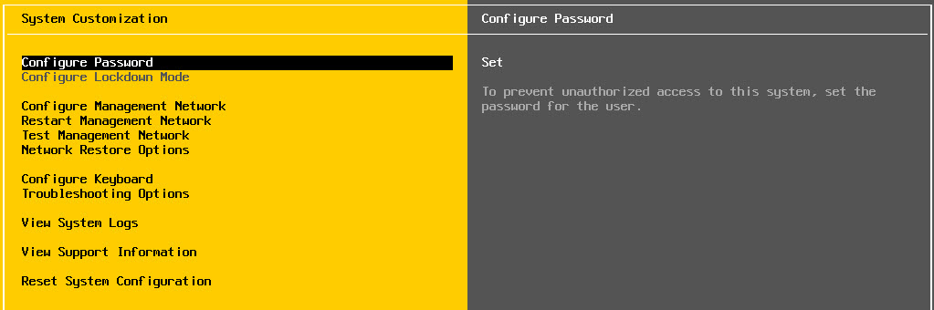](https://3.bp.blogspot.com/-P4ic73JAXqY/WpULnOOqyRI/AAAAAAAAUCY/XS_joZjp8DYoxRxxmoOmMppVgW0cNYkBgCLcBGAs/s1600/image9.jpg)

2. Go to Configure Management Network and hit Enter

[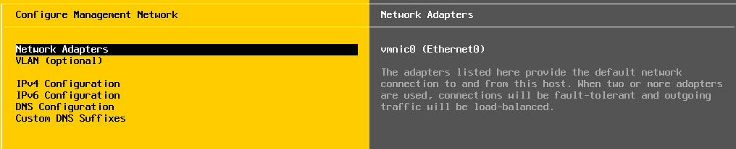](https://3.bp.blogspot.com/-PIYvK42vl1I/WpUMw3tcAyI/AAAAAAAAUCo/HeVGohz8D3o00R6Kp-dinQ-p9Ae0-lyDACLcBGAs/s1600/image10.jpg)

3. Go to Network Adapter and select the correct adapter which you want to use it as management network adapter.  
  
Then go to IPv4 configuration

[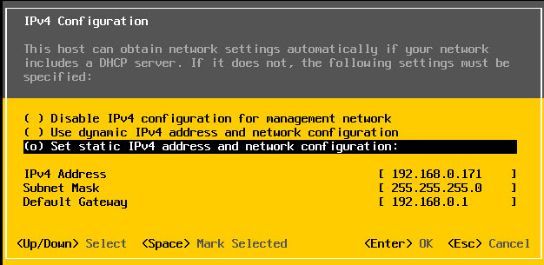](https://4.bp.blogspot.com/-1mwL6VcDemQ/WpUNoelFWFI/AAAAAAAAUCw/W08pDBzW1Tgdn8zfKddaamOEV2DQuzH4wCLcBGAs/s1600/image11.jpg)

4. Select Set static IPv4 address and fill all the required tabs then click OK  
  
5. Go to DNS configuration and fill all the DNS servers and Hostname for the server.

[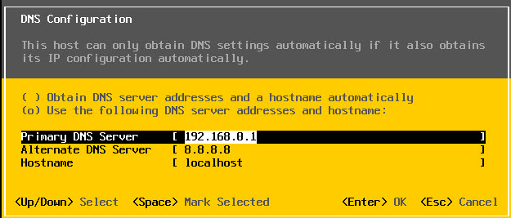](https://4.bp.blogspot.com/--qH7gJUwJoo/WpUN_opVm2I/AAAAAAAAUC4/NGjSy9k7oT0Qh_lSR6Ca-LL6S-yjCSNQwCLcBGAs/s1600/image12.jpg)

6. Press Esc key to go back to the main console and then Y when the below windows prompts to save and Restart the Management network

[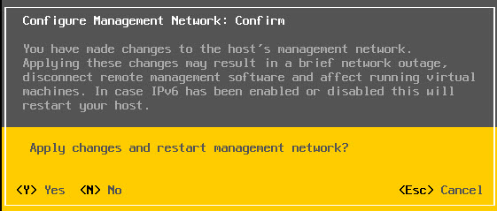](https://2.bp.blogspot.com/-OqjbTDoQ-nU/WpUOizre-MI/AAAAAAAAUDA/tsffIXlP9esB8LpdNrPhEKKz5LQ4TwvEACLcBGAs/s1600/image13.jpg)

7. Select Test Management Network in main menu and click enter to start the test

[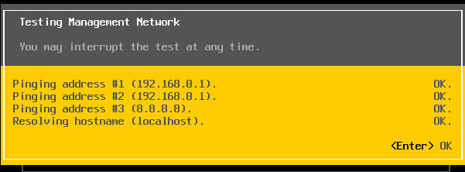](https://3.bp.blogspot.com/-cXsk9w8V9Xs/WpUPROUgBTI/AAAAAAAAUDM/zbGeMAmTgH4gvsayg5YH64wBj5L12-SmwCLcBGAs/s1600/image14.jpg)

If the gateway and DNS test pass then your Network configuration is correct or else you have made some mistake while configuring the Management network  
  
**NOTE:** If the Hostname doesn't resolve then make entry for the proper host name in your DNS server. If the Resolving hostname fails you can use the IP to access.  
  
To connect to vSphere Web client go to any browser and enter the IP with https:// then an certificate error page appears  
  
Click Advanced and proceed to the website unsafe. it will prompt to **vSphere Web client**

[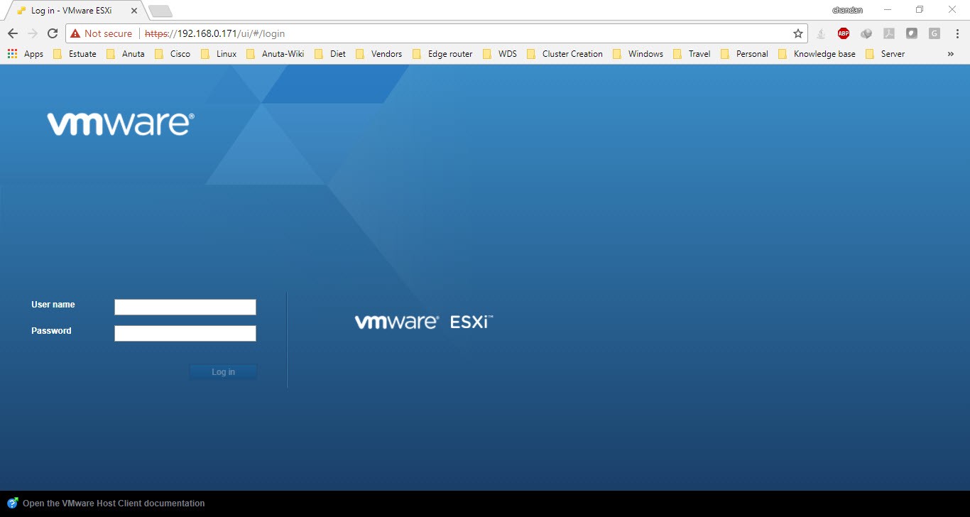](https://2.bp.blogspot.com/-a0QYUBDRjrE/WpUQvaiIYiI/AAAAAAAAUDY/2_G9r-n10pA6IbsVD6CKsEZvv__EVrrBQCLcBGAs/s1600/image16.jpg)

Provide the correct root username and password and login to Esxi 6.5 Web client

[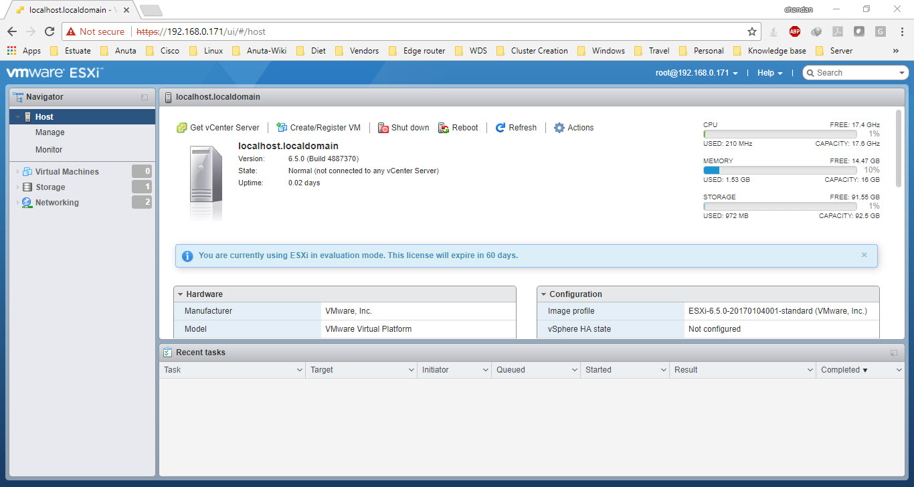](https://2.bp.blogspot.com/-prTwxlhUgow/WpUQ5wudhgI/AAAAAAAAUDc/r9XpvvMvN9EsauoDFg6mmjRtpV2ChYJDACLcBGAs/s1600/image17.jpg)